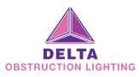

Helipad Beacon– HL 12-A
Data Sheet
Rev: First Edition

Helipad LED Navigation Beacon

The HP 12-A LED heliport beacon is used on a heliport where long range visual guidance is considered necessary or identification of the heliport may be difficult due to surrounding lights.

The heliport beacon shall be located on or adjacent to the heliport preferably at an elevated position and so that it does not dazzle a pilot at short distance.

This beacon is a requirement as per the ICAO recommendations.

Features
- White Flashing
- AC100V-250V universal voltage operated
- Aluminum alloy housing
- Optic reflector lens design makes beam narrower and more concentrated
- Light source uses LED (light emitting diodes) with an expected life-span in excess of 100,000 hours
- Built-in surge protection module for use in harsh environment

Application
- High-rise building marking
- Heliports
- Surface Heliports
- Elevated Heliports
- Offshore
- Crane machines
- Airfield

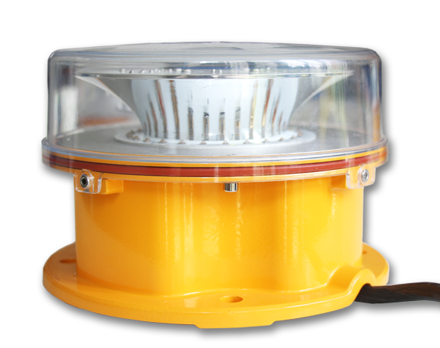

Technical Parameters
Light Characteristics
Light source | High efficiency LEDs
Color | White
Lifespan of LED | 100,000 hours
Light intensity | Compliance to ICAO Annex14 photometric.  10°：250cd;  7°：750cd;  4°：1700cd;  2.5°：2500cd;  1.5°：2500cd;  0°：1700cd;
Flash frequency | 2fps
Electrical Characteristics
Operating Mode | AC 100V~250V; 48V DC or other customized
Power Consumption | 15W
Physical Characteristics
Body/Base Material | Casting Aluminum and black powder coating finish
Lens Material | Polycarbonate UV stabilized, good impact resistance
Lens above the grade | After installation the lens is 10mm above the grade
Overall Dimension(mm) | φ210mm×140mm
Mounting Method | 126mm×126mm×M10
Weight(kg) | 3kg
Environmental Factors & Others
Ingress Grade | IP65
Temperature Range | -40℃ to 60℃
Wind Speed | 80m/s
Quality Assurance | ISO9001:2008

- General Layout of Structure & Mounting Details
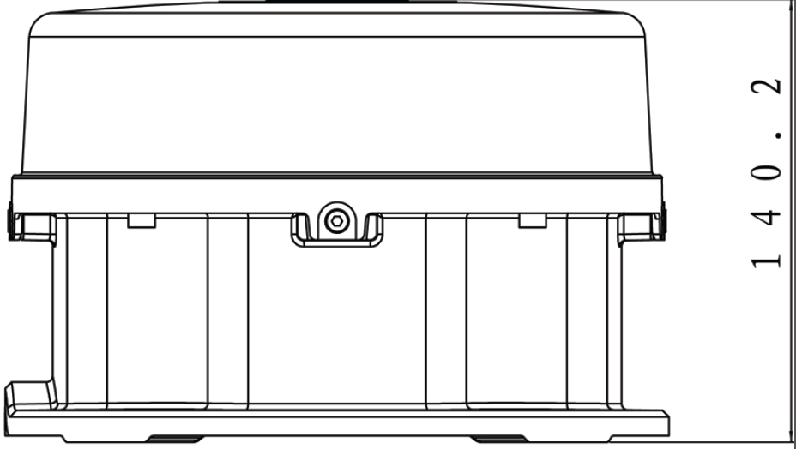 | 