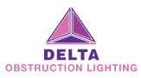

Helipad Elevated Flood Light – HP Fl-60
Data Sheet
Rev: 1.0V

Helipad LED Flood Light
HP Fl-60 - The helipad flood light is a steady burning white LED light which is suitably installed on a flat surface. Floodlights are used to illuminate the surface of helipads, ensuring the surface is well lit for the pilot.

Typical Applications
- Surface level helipad
- Elevated helipad
- Shipboard helipad

Key Features
- Reflective lens consists of a toughened glass material made with excellent impact resistance, thermal stability and great transparency.
- Casing of the light unit is of casting aluminum alloy and painted by spraying plastics capable for use outdoors.
- Equipped with a condenser lens which allows a more previse beam distribution.
- Lens hood in front of the lamp reduces the possibility of dazzle.
- Light technology available in LED technology or metal halide lamp technology.
- Built in surge protection device, can be used in harsh environment.
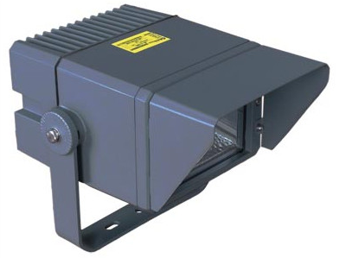

Technical Parameters

Light Characteristics
International standard | ICAO Annex 14 volume II; Heliports | Effective intensity | >8,000lm/metal halide  >1,500lm/LED model
Light technology | LED or Osram metal halide | Available colors | White
Flash | Fixed (no flash)
Electrical Characteristics
Operation mode | Hard wired | Operation voltage | 220V ac/48V dc
Consumption | 70W / metal halide  15W / LED | Multi-lights connection | In parallel
Physical Characteristics
Body material | Casting aluminum alloy | Lens material | Toughened glass
Mounted type | Flat surface mounted | Mounting | 2 x 9mm hubs (diameter)
Overall dims (mm) | 290 x 228 x 210mm | Net weight | 4.6kg
Operating temperature | -55°c to +55°c | Waterproof rating | IP65
Environmental Factors
Humidity | 0 to 98%
Altitude | ＜4,500m
Wind speed | Up to 80m/s
Others
ISO pass | ISO9001:2008

- General Layout of Structure & Mounting Details
